Часть 3.   
1. python manage.py shell

from shop.models import Category, Product

electronics = Category.objects.create(

name="Электроника",

description="Техника и гаджеты"

)

computers = Category.objects.create(

name="Компьютеры",

description="Компьютерная техника",

parent=electronics

)

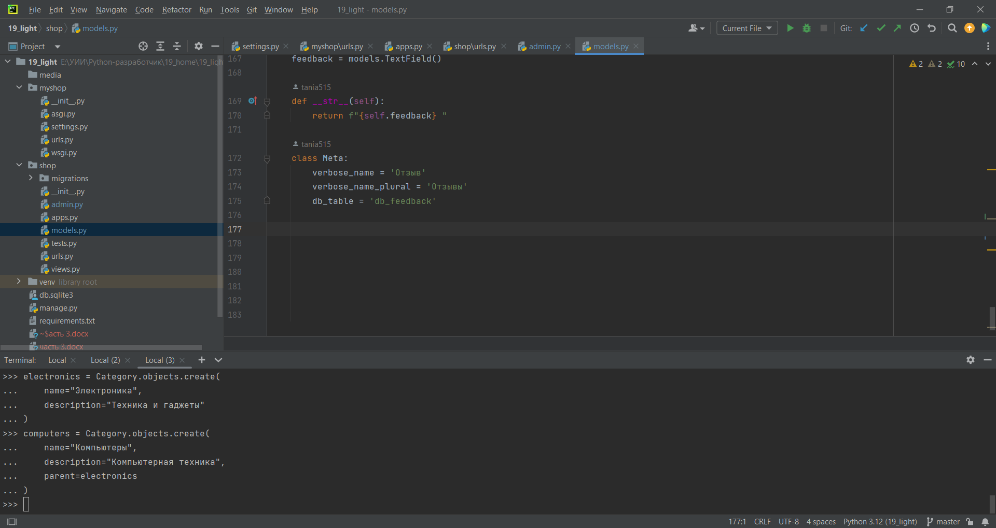

shoes = Category.objects.create(

name="Обувь",

description="Разная обувь"

)

Shoes_f = Category.objects.create(

name="Женская обувь",

description="Обувь для женщин",

parent= shoes

)

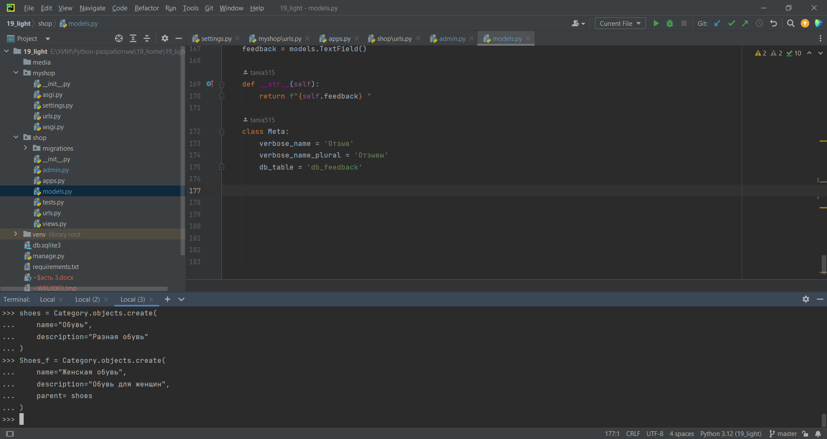

Product.objects.create(

name="iPhone",

description="Смартфон Apple",

price=999.99,

stock_quantity=50,

category=electronics

)

Product.objects.create(

name="MacBook Pro",

description="Ноутбук Apple",

price=1999.99,

stock_quantity=15,

category=computers

)

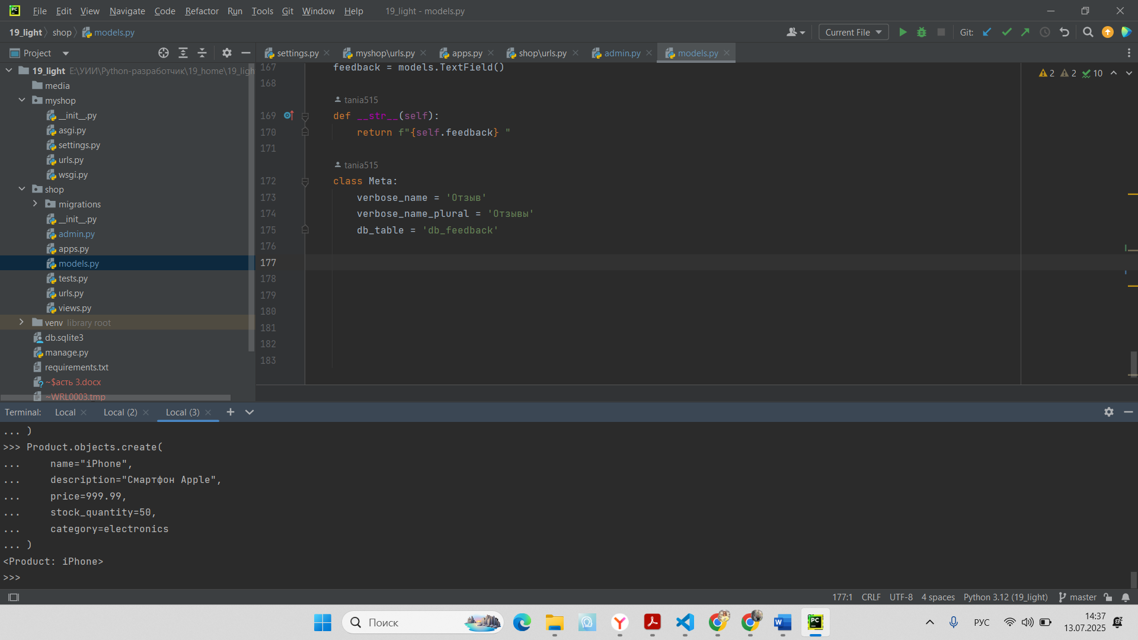

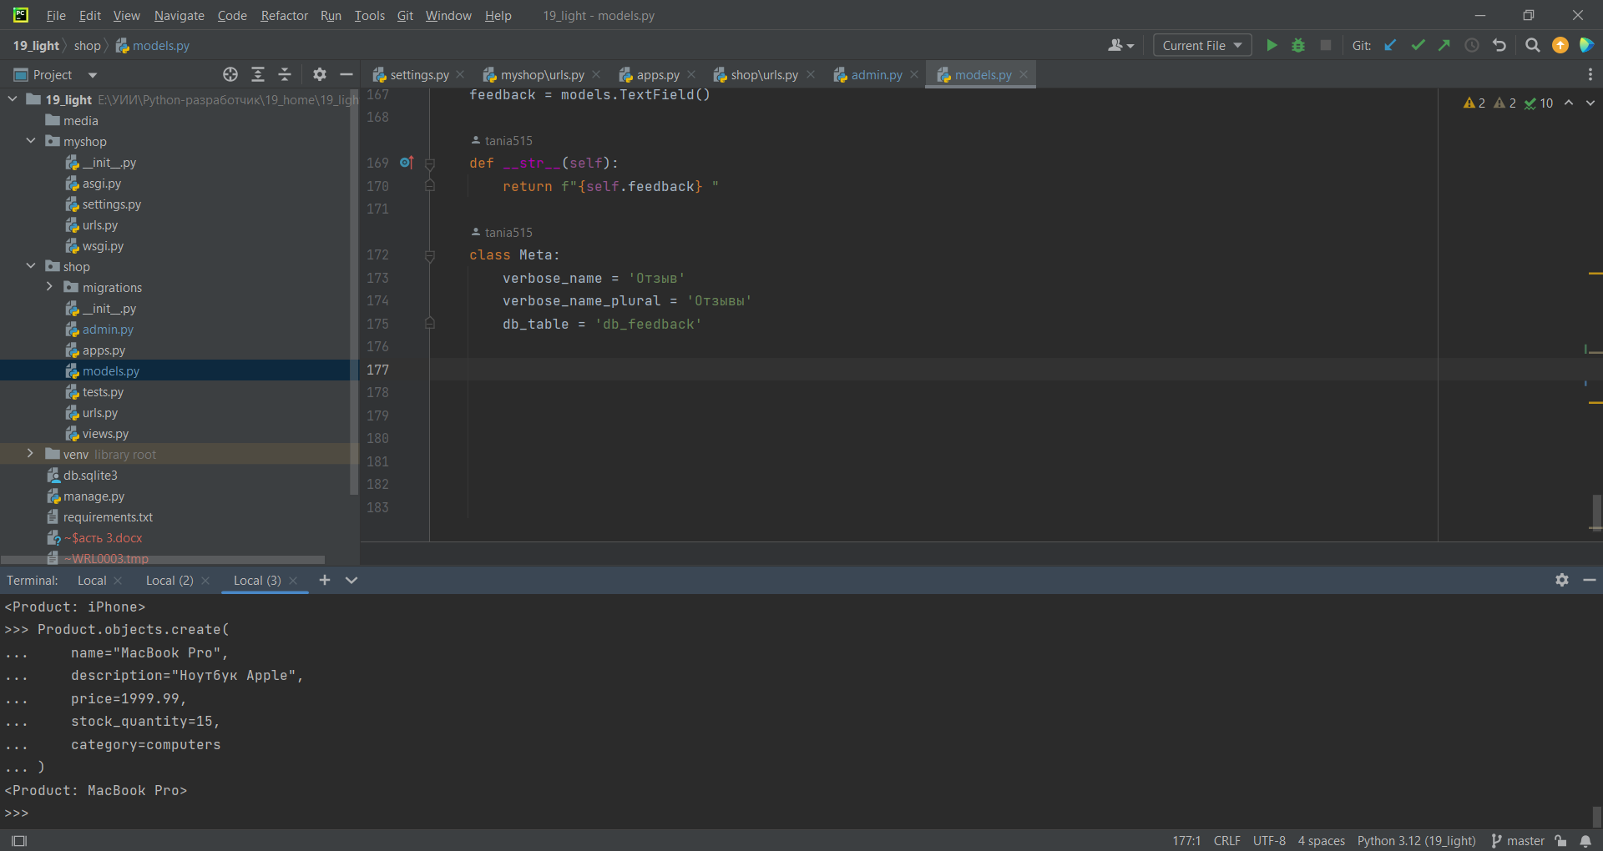

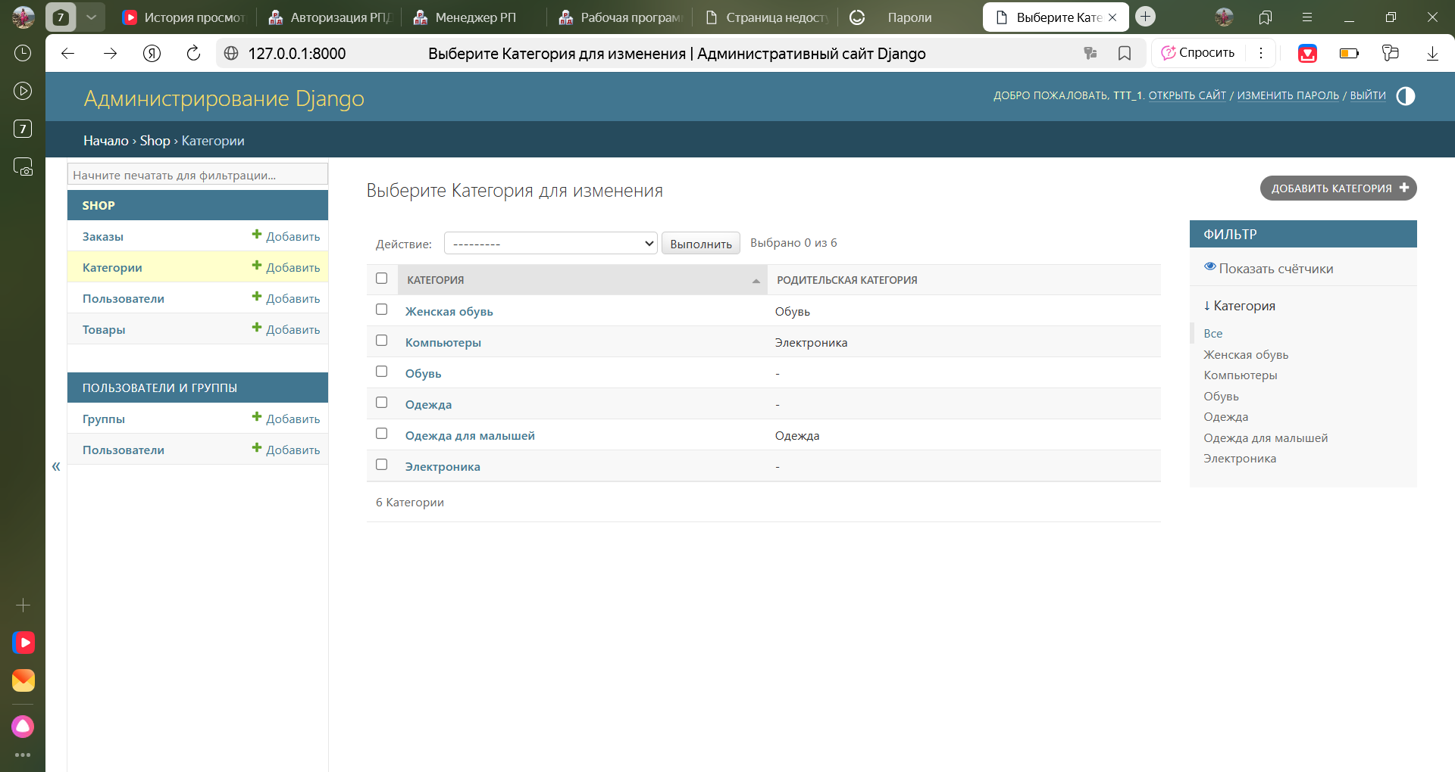

from shop.models import Person, Product, Order, OrderItem

user = Person.objects.create(

fio="user_5",

email="user_5@yandex.ru",

password="user_5_123"

)

order = Order.objects.create(owner=user, total=0)

iphone = Product.objects.get(name="iPhone")

macbook = Product.objects.get(name="MacBook Pro")

OrderItem.objects.create(

item=iphone,

order_item=order,

product_quantity=2

)

OrderItem.objects.create(

item=macbook,

order_item=order,

product_quantity=1

)

2. Запросы

products = Product.objects.filter(category__name="Электроника")

orders = user.orders.all()

from shop.models import Feedback

product = Product.objects.get(name="iPhone")

reviews = Feedback.objects.filter(item__name="iPhone")

products = Product.objects.filter(stock_quantity__gt=10)

